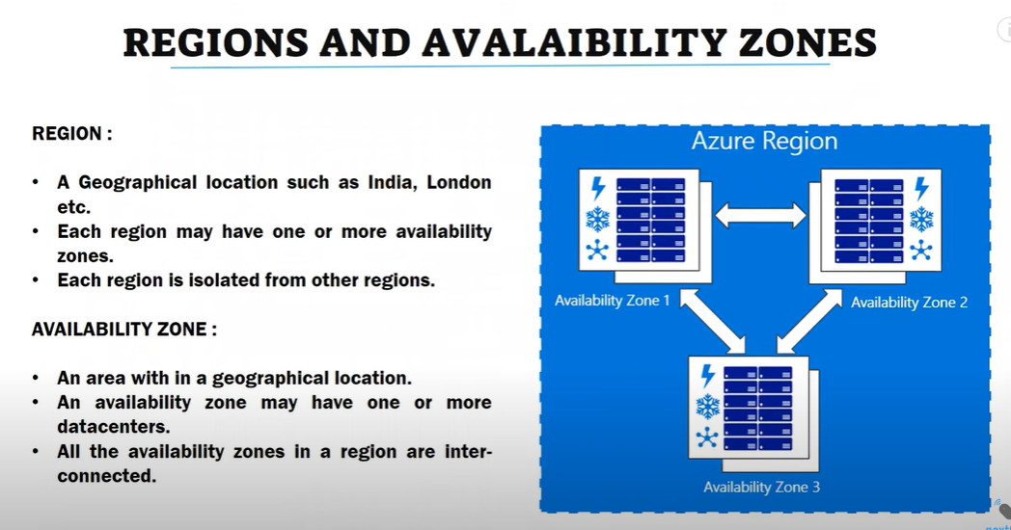

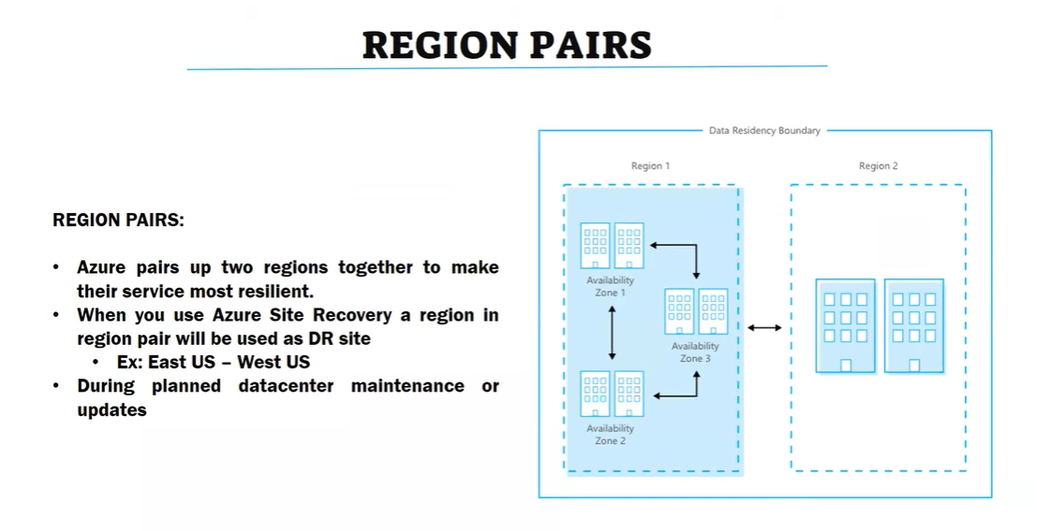

Azure Paired Region  
<https://learn.microsoft.com/en-us/azure/reliability/cross-region-replication-azure>

